Client Side Programming Class 13 Assignment 21

Name: Farel Arden

Student ID: 001201900068

**Farel21a.html**

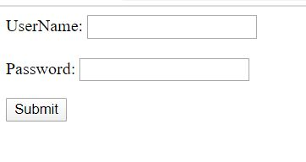

**Farel21b.html**

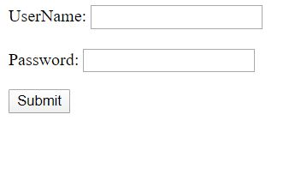

**Farel21c.html**

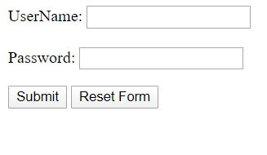

**Farel21d.html**

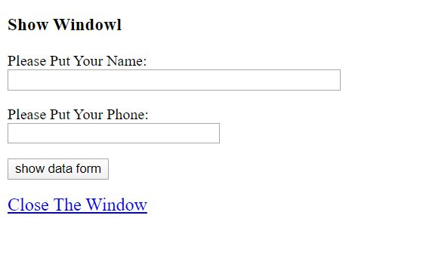

**Farel21e.html**

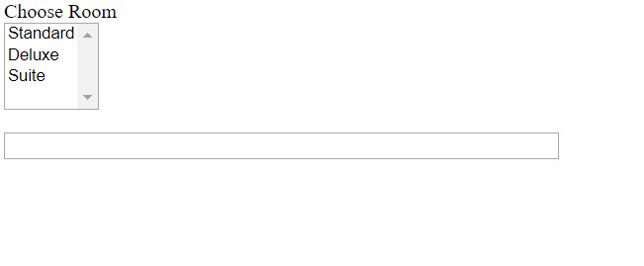

**Farel21f.html**

